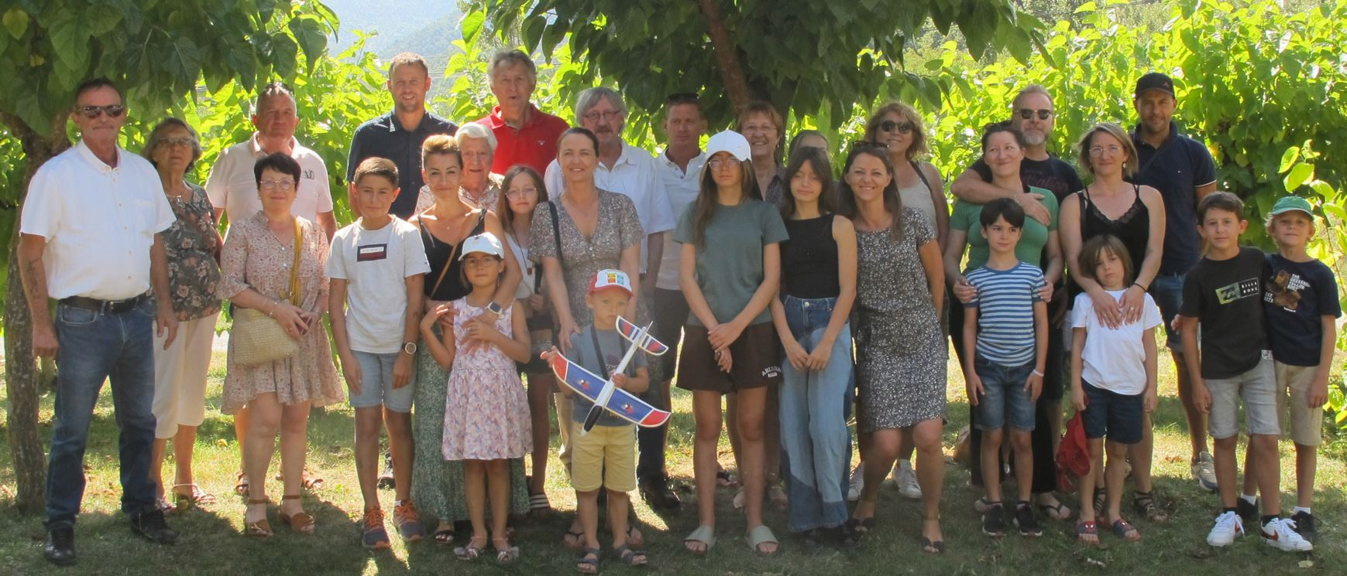

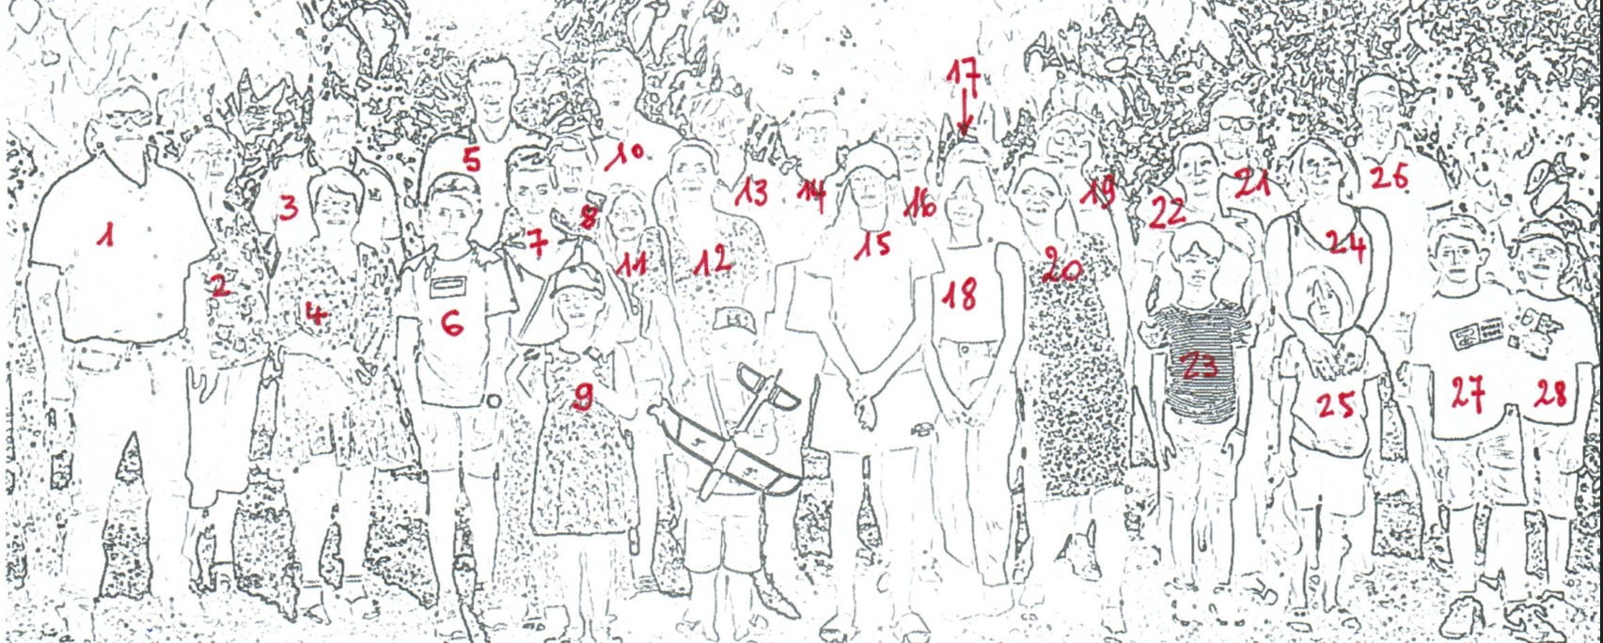

|  |  |  |  |  |  |
| --- | --- | --- | --- | --- | --- |
| 1 | Pierre NUBOIS | 13 | Gérard BUFFIERE | 25 | Jocelyn ALAIZE |
| 2 | Lucette ARBAUD (Vve DEVILLE Armand) | 14 | Samuel NOULIN | 26 | Alexandre BUFFIERE |
| 3 | Jean-Paul DEVILLE | 15 | Loane NOULIN | 27 | Hugo BUFFIERE |
| 4 | Agnès AUBERT (Ep DEVILLE) | 16 | Arlette BUFFIERE (Ep NUBOIS) | 28 | Tom BUFFIERE |
| 5 | Matthieu BUFFIERE | 17 | Sabine AURAIX (Ep BUFFIERE Gérard ) | avion | Léo GUEDON |
| 6 | Romain BUFFIERE | 18 | Clarisse ALAIZE |  |  |
| 7 | Marlène BRUNET MANQUAT(Ep BUFFIERE Alexandre) | 19 | Marie-Claude BONTOUX ( Ep BUFFIERE Maurice) | + | Florent NUBOIS |
| 8 | Rosa ARBAUD (Vve BUFFIERE Germain ) | 20 | Muriel NUBOIS ( -- GUEDON ) |  |  |
| 9 | Louise BUFFIERE | 21 | Gaëtan PENCREAC’H |  |  |
| 10 | Maurice BUFFIERE | 22 | Mélanie BUFFIERE ( Ep PENCREAC’H) |  |  |
| 11 | Ines NOULIN | 23 | Eliot PENCREAC’H |  |  |
| 12 | Rachel NUBOIS (Ep NOULIN) | 24 | Eléonore BUFFIERE (--ALAIZE) |  |  |